Sprint 1 Retrospective

**✅[spike]User story 0** - “I want to have organized documentation. So that we have a solid base to start our project”

**✅[spike]User story 1** - “As a team member I want to have everyone set up on Github. So that everyone has a foundation to start the project.”

**✅[spike]]User story 2** - “ As a team we want to design the application page flow. So that we have a good Idea as we are building the application of where it is going”

**✅[spike]]User story 3** - “As a team we want to design the flow of the interactions between the front and back ends of the project so that all team members have a good idea of the overall structure of the project and how the firebase database interacts with the front end”

**✅User story 4** - “As a service provider I want to be able to sign up and sign in to the app. So that there is security and personalization in the app. And I can contact a service provider once I have signed in.”

**❌User Story 5** - “I want to create a profile that contains my name, service, rate, pictures and bio so that customers may see them.”

**❌User Story 6** - “As a service provider I want to update my profile. So that provider posts stay current”

**❌[spike]]User story 7** - “As a team I want the user interface mockups on figma so that we have something that we will build towards as we do the front end encoding”

Total user story hours: 18.25 hours

❌Spike 1: How to add images to firebase. (1 ideal hour)

❌Spike 1.5: How to add / update / query firebase documents (2 ideal hours)

❌Spike 2: How to google auth. (1 ideal hour)

❌Spike 3: read about MVVM. (Model-View-ViewModel) (.3 hours)

❌Spike 4: learn SwiftUI basics / best practices / common pitfalls. (3 ideal hours)

Total spike hours: 7 hours

Total hours of ideal work: ~26 hours

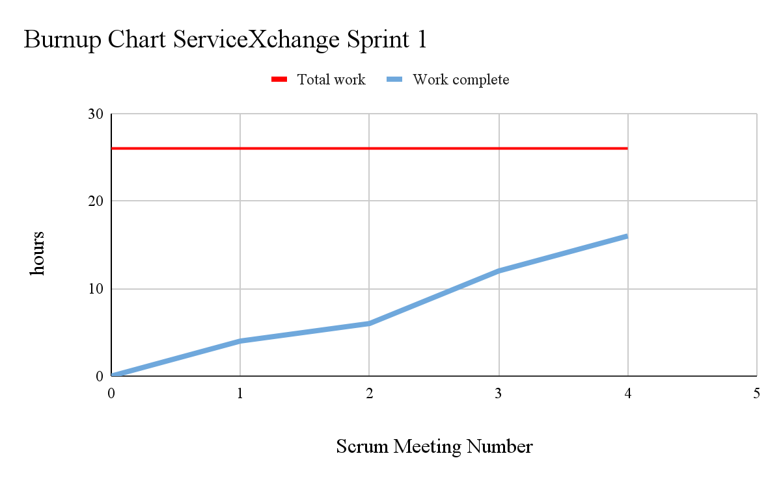

Stop:

* Listing Spikes as their own thing. In the future we will make the spikes more specific to work that has to be done.
* Going forward we will stop talking as much about the high level goals and focus on the specifics of each of our smaller parts of the project that we are working on

Start:

* Be more on top of using our scrum board. We can also break large tasks into smaller ones as we see fit so that we can better document our progress as we continue forwards
* As we do more code make sure that we comment the heck out of it. This will make our code more understandable. Also it will help all of us learn faster.
* Committing more code, even if it is not all the way done. By committing more frequently we can better collaborate and see our progress.
* Being more specific in the work that you will do before the next scrum meeting and holding members to the work that they say that they will do

Continue:

* Great meeting and scrum attendance
* Working together and keeping everyone on the same page
* Good moral and humor at our team meetings
* Continue to get work done!